**CHAPTER 1**

**INTRODUCTION**

* 1. **BACKGROUND**

Agriculture is considered as the basis of life for the human species as it is the main source of food grains and other raw materials. It plays vital role in the growth of country’s economy. It also provides large ample employment opportunities to the people. Growth in agricultural sector is necessary for the development of economic condition of the country [1].

Agriculture in Nepal has long been based on subsistence farming, particularly in the hilly regions where peasants derive their living from fragmented plots of land cultivated in difficult conditions. Government programs to introduce irrigation facilities and fertilizers have proved inadequate, their delivery hampered by the mountainous terrain. Population increases and environmental degradation have ensured that the minimal gains in agricultural production, owing more to the extension of arable land than to improvements in farming practices, have been cancelled out [2].

Also, farmers face problems due to climate change or due to natural disasters like floods, famines, etc. It raises the topic of smart farming or smart agriculture but the misconception about the smart farming is many people think that smart farming is about automated system which starts the motor pump and start the water flow. But people have failed to notice that what if the system does analysis the data of their field and give suggestions about watering, the type of vegetables they can grow in their land according to weather and seasons. The actual smart agriculture should monitor as well as either take required decisions or give appropriate suggestions for the plant/crop. The collected data provides the information about different environmental factors which in turns helps to monitor the system.

* 1. **MOTIVATION**

This is a project from the motivation of the farmers working in the farm lands who are solely dependent on traditional way of farming. In recent times, the farmers have been using fertilizers, insecticides & new seeds of high-yield varieties for the high production of crops without taking care of the change in environment and the quality of the soil. Moreover, various project such as smart irrigation system, agricultural monitoring system, etc. are introduced for helping in increasing the agricultural production but most of them are not effective and efficient as they seem. Also, those projects lag the interaction with farmers so we are introducing ‘KRISHI SATHI’ as our project which suggests the best yielding crops & conditions by monitoring all the factors such as: Humidity of Soil, pH of Soil, Environment Condition, Previously Collected data & Weather.

**1.3 PROBLEM STATEMENT**

In case of Nepal, the land reclamation and settlement occurrence, environmental degradation and ecological imbalance resulting from deforestation prevented agricultural production progress. Also, many farmers still use the traditional methods of farming which results in low yielding of crops and fruits. The government is trying to increase the agricultural production and diversify the agricultural base focusing only on irrigation, the use of fertilizers, insecticides & new seeds of high-yield varieties. Due to the lack of knowledge of environmental change as well as the quality of soil to the farmers, the production is low.

Also, various agricultural technologies have been introduced for helping to increase the crop production but due to their own limitations of size, cost, manpower & efficiency they seem impractical to the normal farmers. So, there is a requirement of a practical, affordable, efficient & portable assistant to the farmers to increase the agricultural production.

**1.4 OBJECTIVES**

The objective of this project is:

* To develop a system that is capable of collecting and analyzing big data in agriculture in order to maximize efficiency.
* To provide efficient suggestions to the farmers about the best yielding for increasing the production.

**1.5 SCOPE**

Farmers have already begun employing some high tech farming techniques and technologies in order to improve the efficiency of their day-to-day work. Sensors placed in fields allow farmers to obtain detailed maps of both the topography and resources in the area, as well as variables such as acidity and temperature of the soil. They can also access climate forecasts to predict weather patterns in the coming days and weeks.

The automated farms can yield more production of crops. The requirement of the atmosphere of the crop/plant can be fulfilled due to the controlled atmosphere. Farmers can use their smartphones to remotely monitor their equipment, crops, and livestock, as well as obtain stats on their livestock feeding and produce. They can even use this technology to run statistical predictions for their crops and livestock.

All of these techniques help make up precision farming or precision agriculture, the process of using satellite imagery and other technology (such as sensors) to observe and record data with the goal of improving production output while minimizing cost and preserving resources. This can also make farming as a nearly zero loss business [3].

**CHAPTER 2**

**LITERATURE REVIEW**

In [4], they proposed a smart Agriculture System (AgriSys) that can analyze an environment and intervene to maintain its adequacy. The system had an easy to upgrade bank of inference rules to control the agricultural environment. AgriSys mainly looked at inputs, such as, temperature, humidity, and pH. The system also could deal with desert specific challenges, such as, dust, infertile sandy soil, constant wind, very low humidity, and the extreme variations in diurnal and seasonal temperatures. The system also provided increased productivity, enhanced safety, instant interventions, and an advanced life style. The system made was ubiquitous as it enables distant access.

In [5], they have made a connected farm based on IoT systems for smart farming systems. They have used IoT to provide Internet connectivity for the sensors and controllers of the connected farm, they have deployed the Cube, a standardized device software platform for IoT devices. They also have used the Mobius, an IoT service platform (also one M2M-compliant) that provides REST APIs with which the data collected from sensors (e.g., CO2 sensor) can be retrieved, but also the control commands can be sent to controllers (e.g. air conditioner). They had implemented a smart phone application that allows end users to remotely monitor and control their connected farm, e.g., turn on air conditioner by pushing a button on the smart phone.

**CHAPTER 3**

**THEORETICAL BACKGROUND**

**3.1 Arduino UNO**

Arduino Uno is a microcontroller board based on the ATmega328P. It has 14 digital input/output pins (of which 6 can be used as PWM outputs), 6 analog inputs, a 16 MHz quartz crystal, a USB connection, a power jack, an ICSP header and a reset button. It contains everything needed to support the microcontroller; simply connecting it to a computer with a USB cable or power it with a AC-to-DC adapter or battery to get started.

"Uno" means one in Italian and was chosen to mark the release of Arduino Software (IDE) 1.0. The Uno board and version 1.0 of Arduino Software (IDE) were the reference versions of Arduino, now evolved to newer releases. The Uno board is the first in a series of USB Arduino boards, and the reference model for the Arduino platform; for an extensive list of current, past or outdated boards see the Arduino index of boards.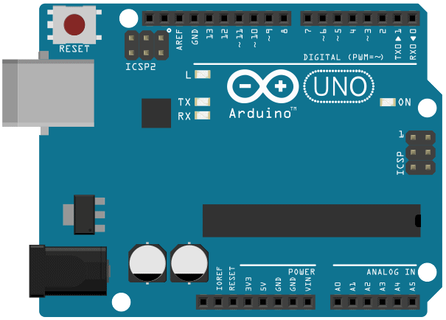

**Figure 1:** Arduino UNO

**3.2 SKU: SEN0161**

SKU_SEN0161 is an analog pH meter. It has built-in simple, convenient and practical connection and features. It has an LED which works as the Power Indicator, a BNC connector and PH2.0 sensor interface. To use it, just connect the pH sensor with BNC connector, and plug the PH2.0 interface into the analog input port of any Arduino controller. If pre-programmed, you will get the pH value easily. Comes in compact plastic box with foams for better mobile storage.

**Applications**

● Water quality testing

● Aquaculture

**Specification**

● Module Power: 5.00V

● Module Size: 43mm×32mm

● Measuring Range: 0-14PH

● Measuring Temperature: 0-60 ℃

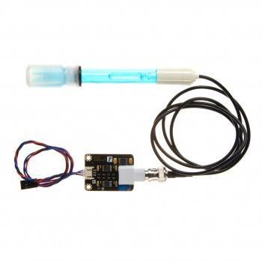

**Figure 2:** SKU_SEN01618

**3.3 Wi-Fi Bee-ESP8266**

It is a Serial-to-WIFI module using XBEE design in a compact size, compatible with XBEE expansion base, applicable to a variety of 3.3V single-chip system. It can be used for Arduino, wireless data transfer, remote control. On-board switch can be used to easily select the Startup module or Upgrade firmware.

ESP8266 has a powerful on-chip processing and storage capacity, built-in 32-bit processor, built-in LWIP protocol stack. Support AP+STA mode co-exist. And you could configure various parameters via AT commands.

**Specifications**

1. Wi-Fi Direct (P2P), soft-AP

2. Built-in TCP/IP protocol stack

3. Built-in low-power 32-bit CPU: can work as an application processor

4. Support WPA WPA2/WPA2-PSK encryption

5. Support UART interface

6. Support for TTL serial port to wireless application

7. Working voltage: 3.3V power <240Ma

8. Wireless standard: IEEE802.11b/g/n

9. Frequency: 2.4 GHz

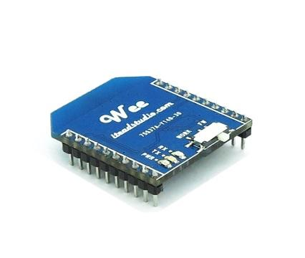

**Figure 3:** Wi-Fi Module ESP8266

**3.4 DHT22 Temperature and Humidity Sensor**

This DHT22 Temperature and Humidity Sensor features a calibrated digital signal output with the temperature and humidity sensor complex. Its technology ensures the high reliability and excellent long-term stability. A high-performance 8-bit microcontroller is connected. This sensor includes a resistive element and a sense of wet NTC temperature measuring devices. It has excellent quality, fast response, anti-interference ability and high cost performance advantages.

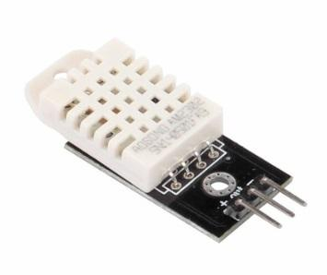

**Figure 4:** DHT22 Temperature and Humidity Sensor

**3.5 EK1361-Soil Moisture Sensor**

It is a soil moisture sensor. It works with official Arduino products with fool-proofing interface and tailored wire.

**Specifications**

➢ Voltage: 3.3V or 5V;

➢ Current: <20mA;

➢ Output voltage: 0~2.3V (2.3V for when it is soaked in water);

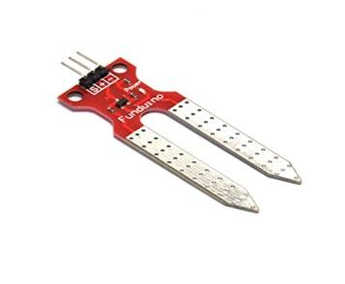

**Figure 5:** EK1361-Soil Moisture Sensor

**3.6 HC-06 Bluetooth Module**

Bluetooth is a wireless medium for the transfer of data. Bluetooth module provides a method to conveniently pass the data from the user to the controller. Bluetooth module can be easily integrated with mobile device to transmit data from user.

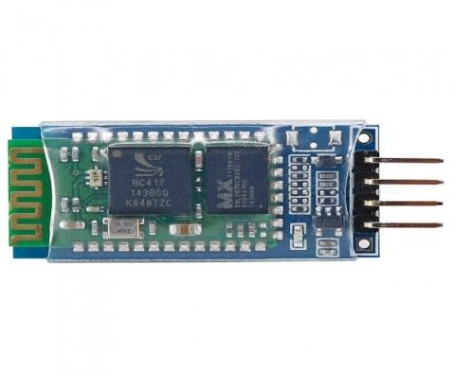

**Figure 6:** HC-06 Bluetooth Module

**3.7 Radiation Sensor ML-8511**

The [ML8511 sensor breakout](https://www.sparkfun.com/products/12705) is an easy to use [ultraviolet light](https://learn.sparkfun.com/tutorials/light/ultraviolet-light) sensor. The MP8511 UV Sensor outputs an analog signal in relation to the amount of UV light it detects. This can be handy in creating devices that warn the user of sunburn or detect the [UV index](http://en.wikipedia.org/wiki/Ultraviolet_index) as it relates to weather conditions.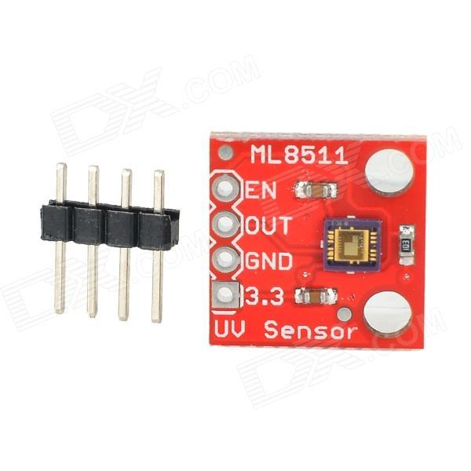

**Figure 7:** Radiation Sensor ML-8511

**CHAPTER 4**

**METHODOLOGY**

* 1. **System Block Diagram**

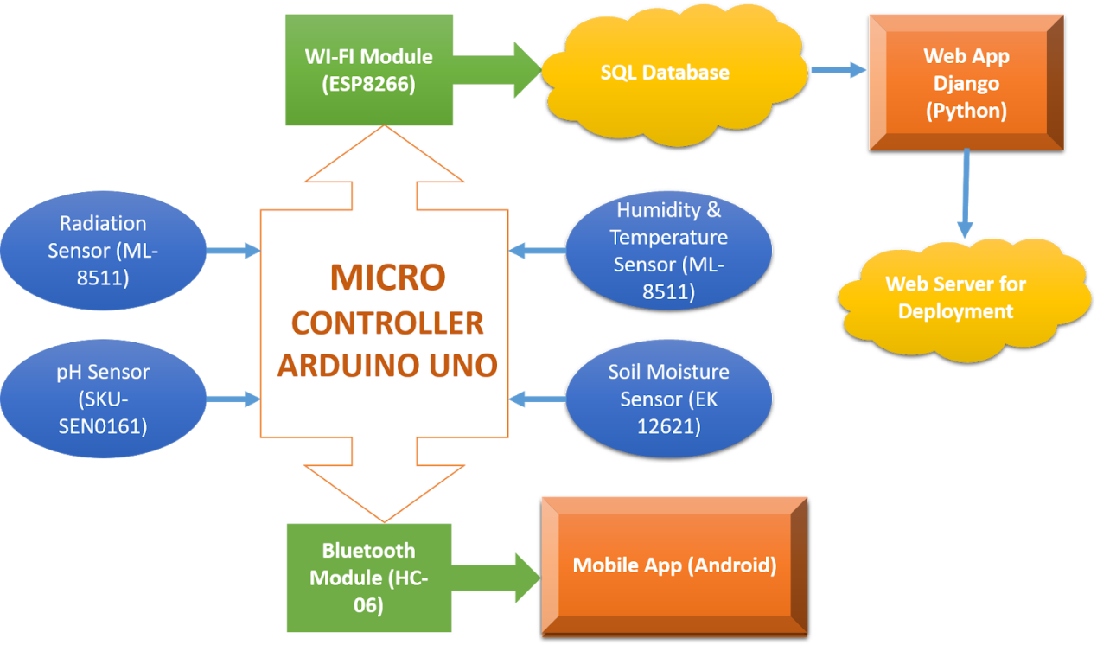

**Figure 8:** Block Diagram of Krishi Sathi

In the proposed system, the main concept implemented is the Internet of Things (IOT). There will be a low level hardware device that will measure different variables of the surroundings like temperature, humidity, soil moisture, pH of the soil, UV radiation, etc. The measured values will then be transferred to a SQL database server which will later be pulled back to a Django web application for further processing. On the other hand, there will be an option to connect the device to an android phone application with the help of a Bluetooth module. The data will then be pushed to the database server using the phone.

The major part of the proposed system will be a hardware device that constitutes of different kinds of sensors such as Soil Moisture Sensor (EK1361), Humidity and Temperature Sensor (DHT22), pH Sensor (SKU: SEN0161) and UV Radiation Sensor (ML-8511). The device collects the surroundings attributes (soil moisture, temperature, pH, radiation intensity) independently and processes it with the help of its microcontroller ATMega328p. The microcontroller will then send the received data immediately to a SQL database server. On the other hand, a Bluetooth module will be connected to the microcontroller so that the user gets to connect to the device locally, and send the data manually through an android application.

The received data will be utilized to process necessary requirements that a farmer needs to take care of, for maximum yield of the crops. To interface the user with the device’s data, a web application will be developed using the Django framework (Python Library). The data received from the hardware device will be analyzed using different machine learning algorithms and researched agricultural datasets in the past. According to the results from different backend machine learning algorithms, a suggestion template will be developed in the web application so that the farmer knows what to do next. The main challenge will be to collect different agricultural datasets that will be used to analyze the data received from the hardware device. The web application will be fully focused on the data visualization and helpful suggestions of each user. So, user authentication is also implemented.

For the development of the android application, we will not be hard coding the application. Rather, we will use MIT App Inventor to develop a working application that will just work as an interface between the hardware device and the web application.

**CHAPTER 5**

**RESULTS**

**5.1 Outputs of project**

Our project demands the technology which can collect the raw data from the field, compare it with the existing data & autonomously learn from it. This type of technology is fulfilled through Machine Learning.

● The datasets for various crops are prepared.

● Machine learning model i.e Random Forest Classifier model is trained with

the datasets resulting the accuracy of 84.21%.

● Hardware setup and circuitry is completed.

● Web application is completed.

● Developed mobile application.

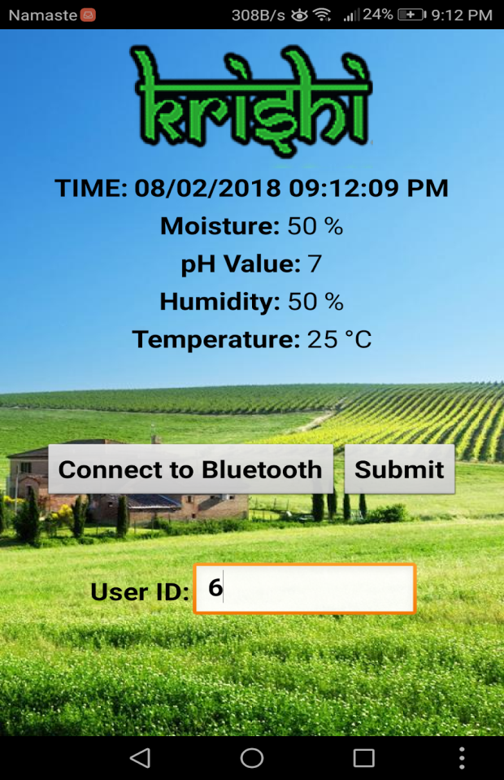

**Figure 9:** Android Application

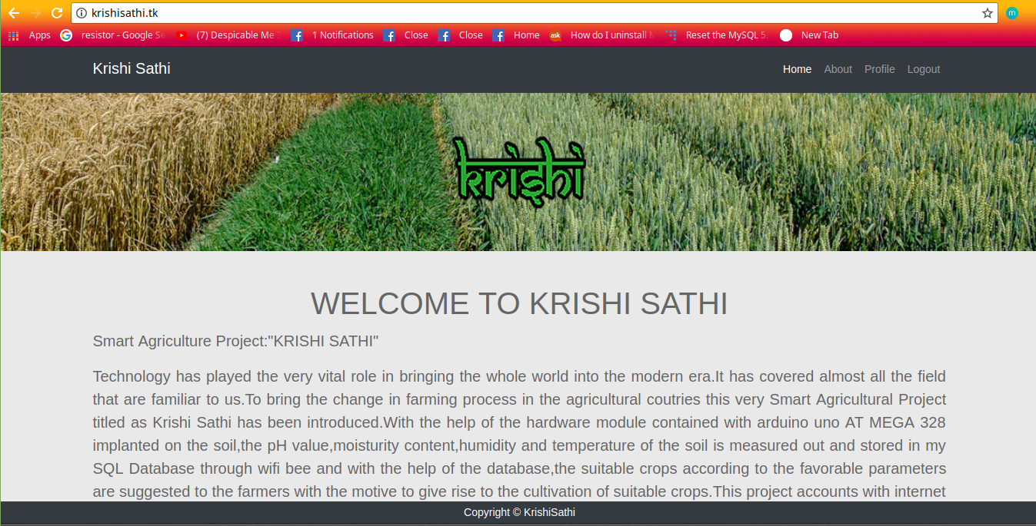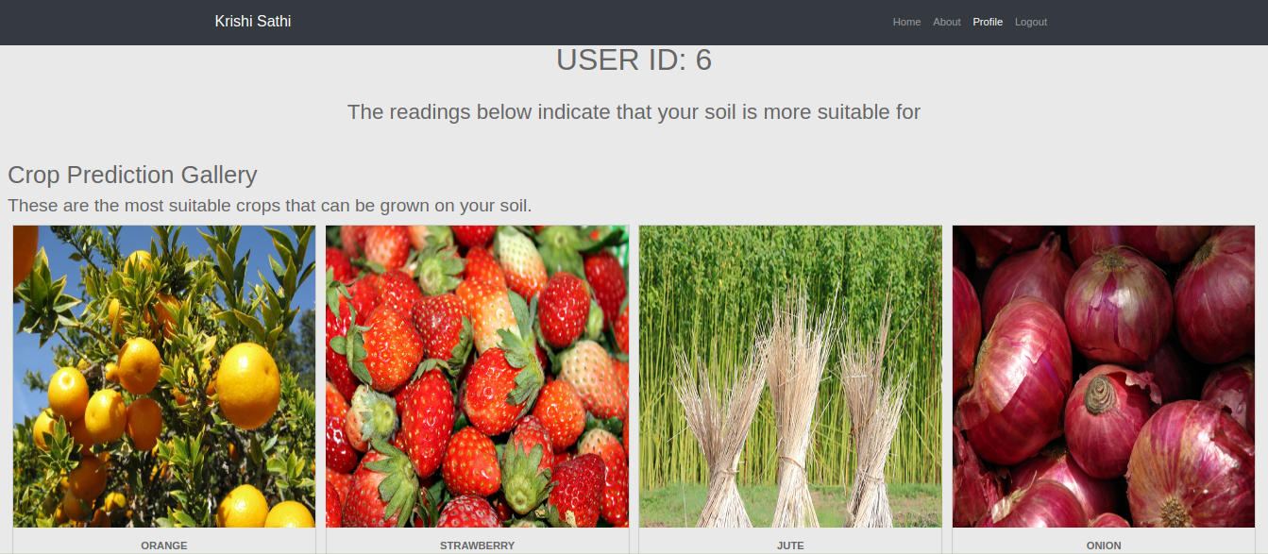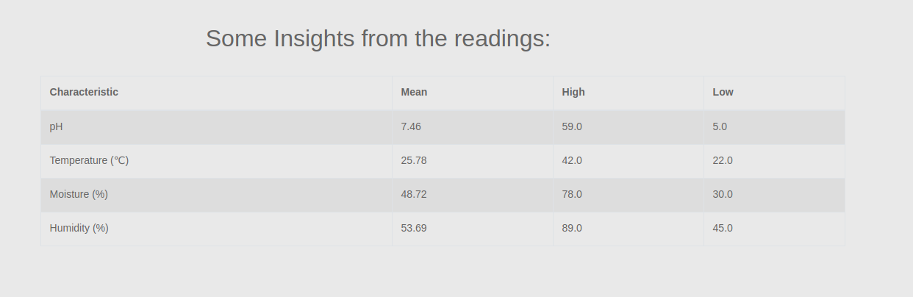

**Figure 10:** Web Application

**Crop Classes**

['grapes', 'rose', 'apple', 'gladiola', 'cauliflower', 'paddy', 'dahlia', 'Onion', 'marigold', 'coffee', 'lily', 'strawberry', orange', 'potato', 'tomato', 'phapar', 'cabbage', 'jute', 'tea', 'blackberry', 'maize'] [7]

The test circuit for the project ‘Krishi Sathi’ is completed. The circuit acts as a single sensor node. It consists Arduino Uno as a main controller and various sensors such as pressure sensor, humidity & temperature sensor, radiation sensor, pH sensor & soil moisture sensor which monitors the real time value. The schematic is shown below

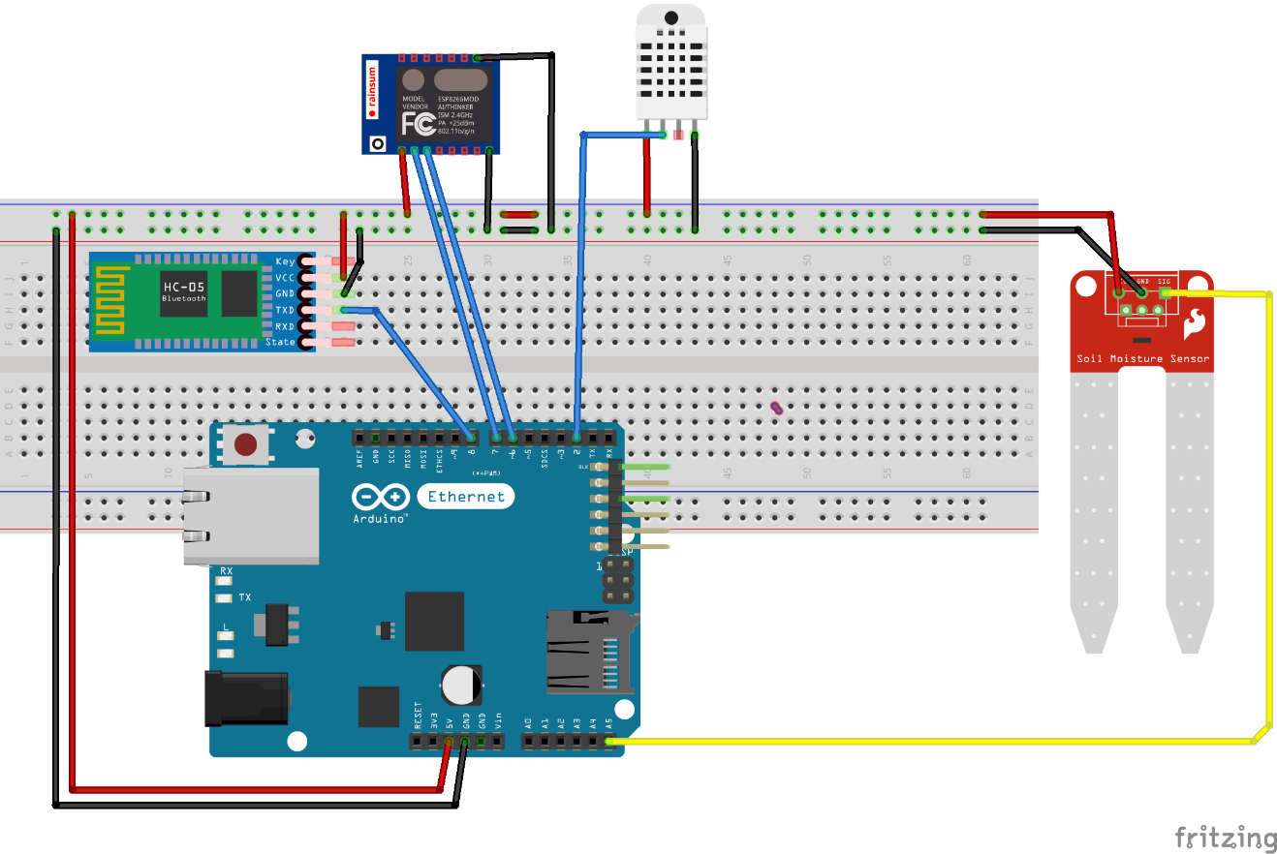

**Figure 11:** Schematic of a sensor node

**CHAPTER 6**

**EPILOGUE**

**6.1 Conclusion**

The project is able to

* Collect and analyze big data in agriculture in order to maximize efficiency.
* Suggest the farmers about the best yielding crop for increasing the production.

**6.2 Future Enhancement**

The project can be enhanced in the following ways:

* The weather station can be integrated to the system for the purpose of getting the weather data’s.
* Multiple sensor nodes can be installed in the field within fixed distance for getting the field data’s and analyzing it.
* Deep learning algorithms can be implemented to the existed system.

**REFERENCES**

[1] S. Balami, 'Nepalese Economics in Agriculture', 2007. [Online]. Available: http://www.nationsencyclopedia.com/economies/Asia-and-the-Pacific/Nepal.html

[2] Wikipedia , 'Agriculture in Nepal', 2017. [Online]. Available: https://en.wikipedia.org/wiki/Agriculture_in_Nepal

[3]L. Boom,’Smart Agriculture’, 2017. [Online]. Available: http://www.businessinsider.com/internet-of-things-smart-agriculture-2016-10

[4]Aalaa Abdullah, Shahad Al Enazi and Issam Damaj, AgriSys (2016): “A Smart and Ubiquitous Controlled Environment Agriculture System Authors”

[5] Minwoo Ryu, Jaeseok Yun, Ting Miao, Il-Yeup Ahn, SungChan Choi, Jaeho Kim(2017): “Design and Implementation of a Connected Farm for Smart Farming System Authors”

[6] Ng Andrew, ’Machine Learning’.[Online]. Available: <http://coursera.org/machine-learning-andrew-ng>

[7] Garner, S.R., et al., Applying a machine learning workbench: experience with agricultural databases, to: Proc. Machine Learning in Practice Workshop. Machine Learning Conference, pp. 14-21, 1995